NOTE: I'm not using a software requirement specification for this... the requirement is simply to produce the most accurate mathematical expression segmentation technique and then to evaluate as objectively as possible.

This intro seems very redundant. #TODO merge the sections of the intro so they are less redundant!!

1. INTRODUCTION
1.1 Purpose

The goal of this project is to enhance the quality of document layout analysis and OCR for printed (non-handwritten) technical/scientific public domain documents which may contain displayed/inline equations, matrices, illustrations, graphs, etc. Automated processing of such documents requires both physical and logical layout analysis techniques to be employed in order to segment and classify zones of interest for correct processing. After physical layout analysis is carried out, regions corresponding to illustrations, plain text, musical notation, and mathematical formulas all must be classified so that they can be processed correctly. The application of this project is in automated processing of digitized public domain text books, articles, dissertations, etc (or non public domain documents with author/publisher consent and due legal permission). Automated document processing has seen widespread use in industrial settings (i.e. automated processing of bank notes or postage envelopes) as well as for Assistive Technology in aiding the blind and/or visually impaired in their accessibility to information. More controversially, document layout analysis and OCR has found use in the “Google Books Initiative” whose founders have envisioned a veritable online “Library of Alexandria” from which all of the world's knowledge could instantly be acquired from anywhere.
The purpose of this work is to increase document layout analysis support for scientific documents by developing and evaluating a mathematical expression detection and segmentation (MEDS) module that can obtain favorable accuracy on a wide range of pages of printed public domain text, compare this module's accuracy to that of a default implementation provided within an existing layout analysis software, Tesseract [refer to tesseract], and to evaluate performance under a wide variety of inputs.

1.2 Problem Statement and Project Scope
Currently, the commercial OCR system best suitable in handling scientific documents is Masakazu Suzuki's “Infty Reader” which can accurately recognize a wide variety of complex mathematical equations as well as matrices, assuming that they are first properly isolated from other, non-math, regions of text. While some of the system's shortcomings can be attributed to the merging or breaking of characters during image scanning, most of the system's errors can be attributed to the improper isolation of the math regions from non-math regions. The system isolates regions of interest based solely upon analysis of the output of a commercial OCR system, Abby Fine Reader. Regions which appear to be “junk output” are deemed as candidates for math recognition. Infty Reader sidesteps the problem of physical and logical layout analysis, relying solely upon whatever physical and logical layout analysis is performed by the proprietary Abby Fine Reader system utilized. The Infty Reader system's degree of document understanding prior to recognition, therefore, is entirely at the mercy of false positive recognitions and/or layout analysis errors made by Abby Fine Reader, which, in and of itself, was not even designed with the layout analysis of scientific/mathematical documents in mind.
Meanwhile, the “Google Books Initiative” project has spurred a great amount of interest in the automated processing of a wide variety of documents ranging from ancient texts, magazines, articles, to scientific/mathematical textbooks, dissertations, etc in over fifty languages. An experimental equation detector, for instance, was implemented as part of Google’s 2011 release of their open source OCR engine, Tesseract. Upon performing a preliminary evaluation of the equation detector on several pages of a public domain calculus text book (Advanced Calculus by Edwin Bidwell circa 1911), it was found that fewer than a fourth of the equation zones were fully segmented (refer to section where this evaluation is carried out). Of all of these fully segmented equation zones, none of them were without at least some false positive pixels and/or under/over-segmentations.
The primary goal of this project is to design, implement, and evaluate a system which can accurately detect and segment regions of text which correspond to mathematical equations and/or expressions. Since a significant problem observed in the existing literature is a lack of objective performance comparison among MEDS modules, this work is tested primarily on public domain documents, with the evaluation software provided freely for academic/industrial use. While the general layout analysis framework of Tesseract will be utilized for this work, a new MEDS module implementation will override Tesseract’s default one. The performance of Tesseract’s document layout analysis framework will be evaluated both under the default MEDS module and the newly implemented one, the results compared, and experiments carried out on printed text from a variety of sources in order to gain insight into how best to increase accuracy over a wide variety of documents while avoiding the problems of overtraining to the largest extent possible.

1.3 Overview
TODO: Provide an overview of this document and its organization. Will do this after done writing everything up REMEMBER THAT THIS WILL BE INCORPORATED INTO THE THESIS METHOD SECTION SO LAY OUT EVERYTHIGN WITH THAT IN MIND...
1.4 Definitions and Acronyms

mathematical expression detection and segmentation (MEDS) module

Put in whatever terminology from tesseract datastructures that i use...
physical segmentation
logical segmentation
other terms.... IMPORTANT: EXPLAIN WHAT A COLUMN PARTITION IS

column partition - a horizontal slice of a column of text at a given vertical location. A column of text would thus consist of several column partitions stacked on top of one another.

CPset = A division of the page into column partitions at a vertical position. Thus a CPset holds a list of column partitions where the horizontal slice of the page at a vertical position contains all of the given column partitions.

^ Refer to hybrid article for more info

define concepts like seeds, merging/growing, etc.....

2. SYSTEM OVERVIEW
Give a general description of the functionality, context and design of your project. Provide any
background information if necessary.

The software to be described herein is designed such that it may be utilized as a modular component working in coordination with other components to produce a full-fledged document layout analysis system. While the document layout analysis system, as a whole, is geared toward the proper segmentation and detection of all zones in an arbitrary printed document image (i.e. normal text, image, halftones, mathematical expressions, musical notation, logos, chemical equations, etc.), the subsystem to be described herein is geared toward only the proper detection and segmentation of mathematical expression regions. This subsystem is to be integrated with an existing layout analysis system, Tesseract [reference], and its results compared to those of a default implementation supplied with the software. The subsystem is then evaluated on a ground truth data set which includes 105 images all taken from public domain texts. Both the groundtruth generation procedure as well as the evaluation method will be herein described. The evaluation method objectively gauges performance by calculating true positive rate, precision, accuracy, false positive rate, false discovery rate, specificity, and negative predictive value all down to pixel-level [refer to shafait]. Both the dataset and evaluation tools are made freely open to the public in hopes that they may be made useful for the objective comparison of the subsystem's performance to any future or existing techniques.

3. SYSTEM ARCHITECTURE
This system consists of three primary components: the ground truth generation module, mathematical expression detection and segmentation (MEDS) module, and the evaluation module. Together, these three modules effectively comprise a test-driven development environment wherein MEDS modules may quickly be interchanged and evaluated against one another for objective performance comparison. All MEDS modules which can be evaluated by this system are fully integrated with Tesseract's document layout analysis software [refer to the hybrid article], and are instantiated by overriding Tesseract's BaseEquationDetect class [refer to the source file]. Tesseract utilizes a hybrid physical layout analysis approach to locate initial column partition candidates on the page which are then corrected through further type-specific document layout analysis techniques (i.e. segmentation algorithms for table, music, math, etc.). While Tesseract provides a default MEDS module, a preliminary evaluation of the module's accuracy [refer to section with specifics] has shown that there is significant room for improvement. Figures [???] and [diagram_fig] illustrate how the groundtruth generation, MEDS, and evaluation modules collaborate in order to foster a test-driven development environment for the enhancement of MEDS accuracy.
The system is first fed a PDF or document image from which the groundtruth is manually generated. The groundtruth will contain the bounding box coordinates for all displayed and embedded math expressions (and may also contain the coordinates of all displayed expression labels) (refer to section for specifics on this procedure). Both the input document image and the groundtruth are fed into the evaluation module which subsequently triggers Tesseract's document layout analysis software. The MEDS module to be evaluated is embedded in Tesseract's layout analysis software such that it is called after initial column partition estimates have been made through Tesseract's hybrid physical segmentation technique [refer to hybrid paper again]. Either Tesseract's default MEDS module can be evaluated or any new MEDS module may override Tesseract's default one so that it can be evaluated. Once the layout analysis software is finished being run on the document image (or multiple images if desired), the results of the MEDS module are evaluated against the groundtruth to obtain various evaluation metrics (refer to section where details are discussed). The resulting metrics for different MEDS modules evaluated on the same input data may then be objectively compared.

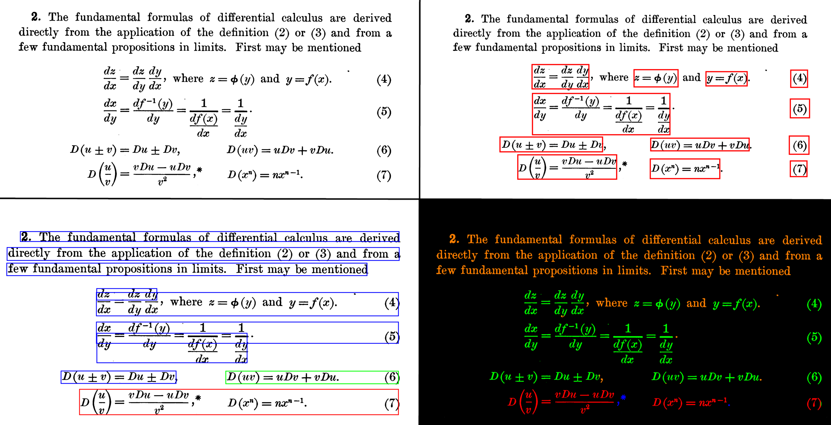Illustration 1: (Top-left) Input image segment. (Top-right) Manually generated groundtruth for input. Segments outlined with red rectangles are individual displayed expressions. (Bottom-left) Output of Tesseract's default MEDS module. Segments outlined with red rectangles are individual displayed expressions, segments outlined with green rectangles are individual embedded expressions, and segments outlined with blue rectangles are normal text. (Bottom-right) Pixel-accurate evaluation results for displayed expressions found in Tesseract's default module after comparing it to the groundtruth. False negative pixels are colored green, false positive pixels are colored blue, true positive pixels are colored red, and true negatives are orange. All background pixels are colored black. Notice that the true positive region at the bottom is undersegmented (a single region should correspond to the three regions).The commas and asterisk are false positives since they are not functionally part of the mathematical expressions.

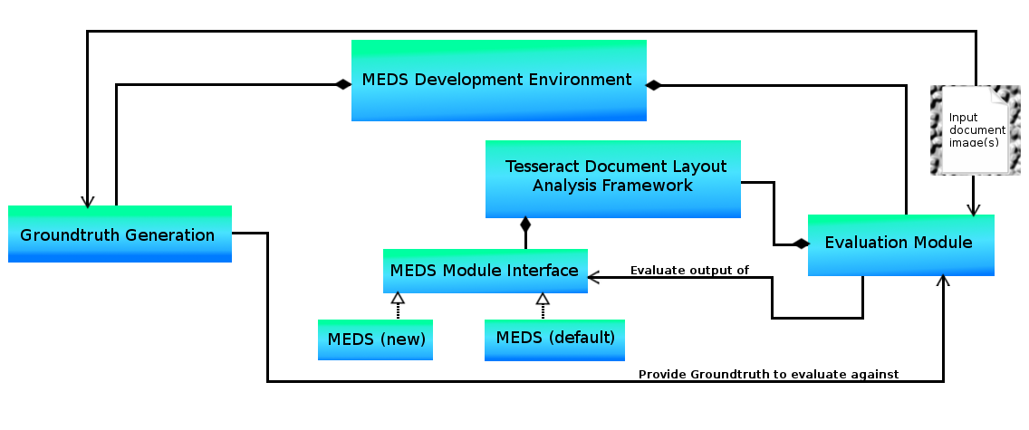Illustration 2: High-level UML-based system architecture overview.

4. DATA DESIGN TODO: Decide whether or not I really need this part... If I do it will have separate sections for the groundtruth generation, evaluation, and layout analysis module (for groundtruth generation show screenshot of user interface.. maybe just move that to teh component design section?????)... Do the next part first, then come back to this and see what can be done if anything is even necessary....
4.1 Data Description
Explain how the information domain of your system is transformed into data structures.
Describe how the major data or system entities are stored, processed and organized. List any
databases or data storage items.

Groundtruth Generation

Evaluation Module

MEDS Module

4.2 Data Dictionary ((???? This section may also be unnecessary...)
Alphabetically list the system entities or major data along with their types and descriptions. If
you provided a functional description in Section 3.2, list all the functions and function
parameters. If you provided an OO description, list the objects and its attributes, methods and
method parameters.

5. COMPONENT DESIGN This will go into greater detail for all of them.. do this one first... and most importantly.. do the MEDS module design first (all the others we've already implemented prior to designing anyway....)

In this section, we take a closer look at what each component does in a more systematic way. If
you gave a functional description in section 3.2, provide a summary of your algorithm for each
function listed in 3.2 in procedural description language (PDL) or pseudocode. If you gave an
OO description, summarize each object member function for all the objects listed in 3.2 in PDL
or pseudocode. Describe any local data when necessary.

Groundtruth Generation (TODO: work on this ONLY after MEDS module design is done!!!!!!)
TODO: Complete this.. Include screen shots of the GUI. Discuss the rules I set out, etc.....

Evaluation Module((TODO: work on this ONLY after MEDS module design is done!!!!!!)
TODO: Detailed description of how I implemented this.. maybe include UML, sequence diagrams etc???

MEDS Module

---

#TODO: convert the displayed expressions which shoudl be embedded to embedded in img 1 and 11 of z_all

Critical to first understand the problem at hand, how best it shoudl be approached. Indicate how much the understanding of the problem varies in the literature (i.e. goes from that of segmenting for math recogntion to finding ways to discard math regions which may harm normal OCR performance). The problem addressed here is that of proper segmentation which can facilitate accurate math recogntition.

Img 6 of advcalc1 set (img3 of full_set) demonstrates how tricky displayed vs embedded expressions can be!!!!!!!!! Decision as to whether a region is embedded or displayed can be somewhat subjective.. Illustrate my logic in how I choose which are. If math expressions appear on a line of text with normal sentence structure, even if that line appears isolated I label the regions as embedded since they are part of a larger sentence structure. If, however, a math expression appears on an isolated text line with improper sentence structure, I label the expression regions as displayed.

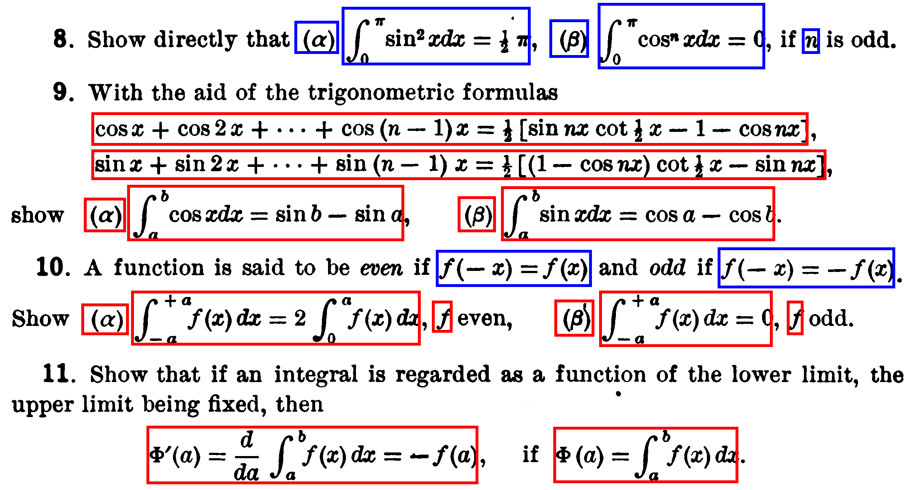

a line separated from text is not necessarily a displayed mathematical expression and give several examples of this!!

NUMBERS SHOULD ONLY BE LABELED AS MATH BASED UPON THEIR CONTEXT!!! quantities can interpreted as mathematical since they inherently involve multiplication. When it is section numbers however, this should not be regarded as mathematical (what are other examples??)
other examples: dates/years aren't inherently mathematical. Decisions of this nature are very important to the usefulness of the MEDS module. False detection of section numbers, dates, etc. as mathetmatical quantities harms overall document analysis performance in that it will result of improper interpretation of the document's contents.

Rules:
- Equation/expression cannot extend to new line unless the resulting segment would be a normal rectangle. This is because the groundtruthing process only results in rectangles, there is currently no support for the segmentation of isothetic blocks. Groundtruth is such that all extending lines which can be segmented as a normal rectangle are merged into a single segmentation. {{An example of where you can and can't extend to multiple lines... You can't when the resulting rectangle would have false positives unless it is made isothetic::

Based on this system an equation does not extend to a new line unless the resulting segment is a rectangle. My current groundtruth approach does not include isothetic shapes, just rectangles. Line extension detection is assumed to be carried out in post because creating a groundtruth for extended expressions is more complex than the simple rectangular approach carried out here (would require isothetic shapes and/or a new parameter indicating which expression to which the current one should be merged).

Example:
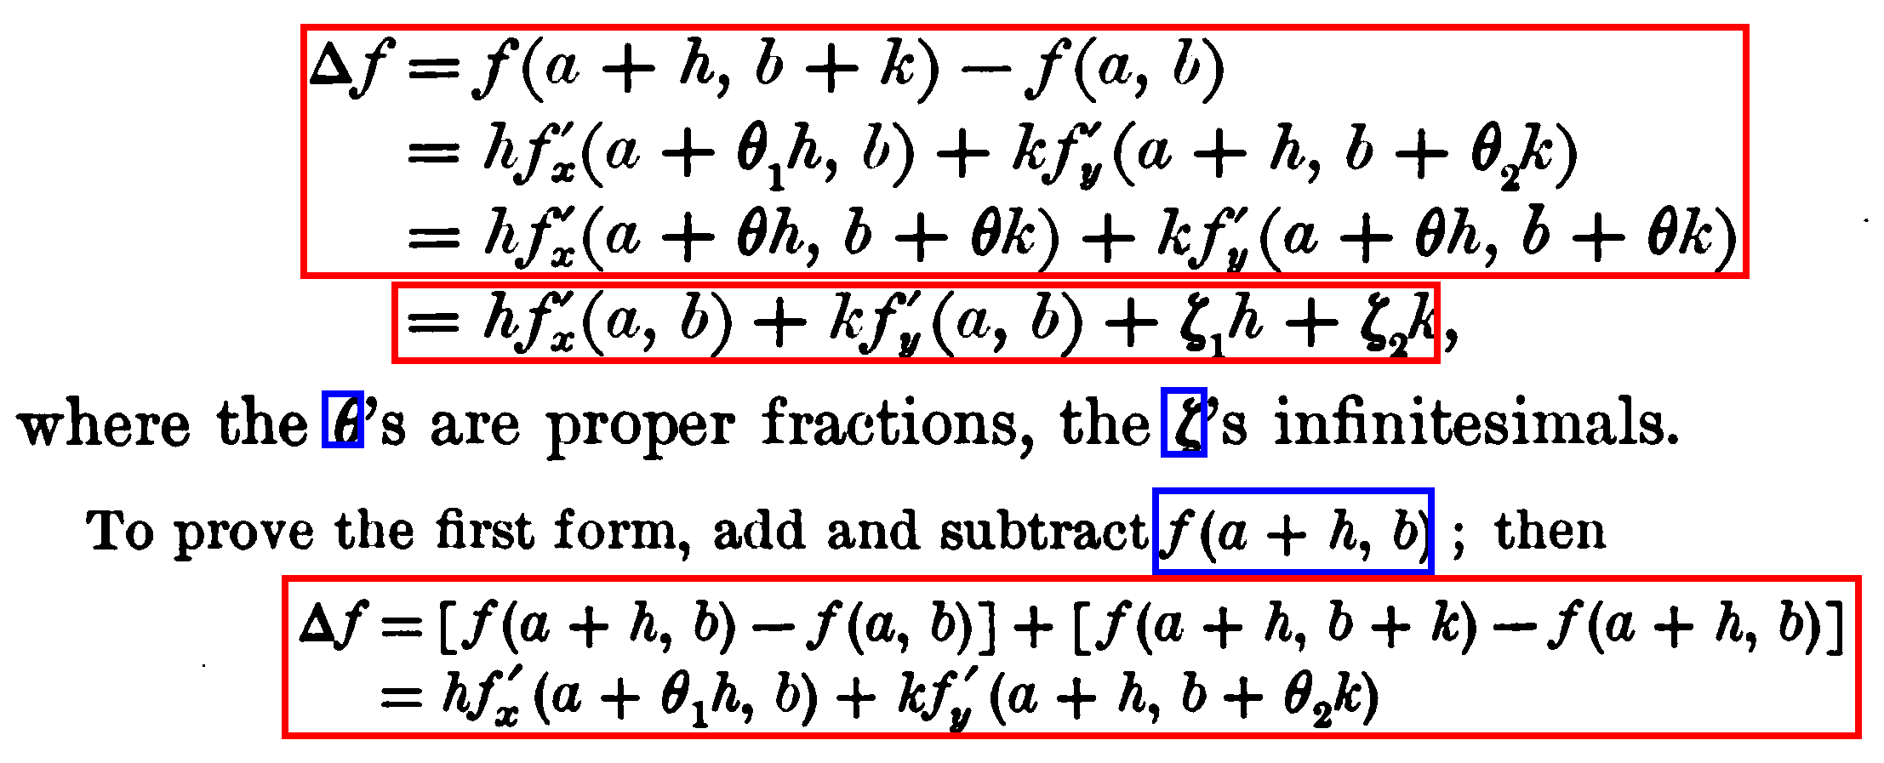
show how it woiuld look as isothetic:
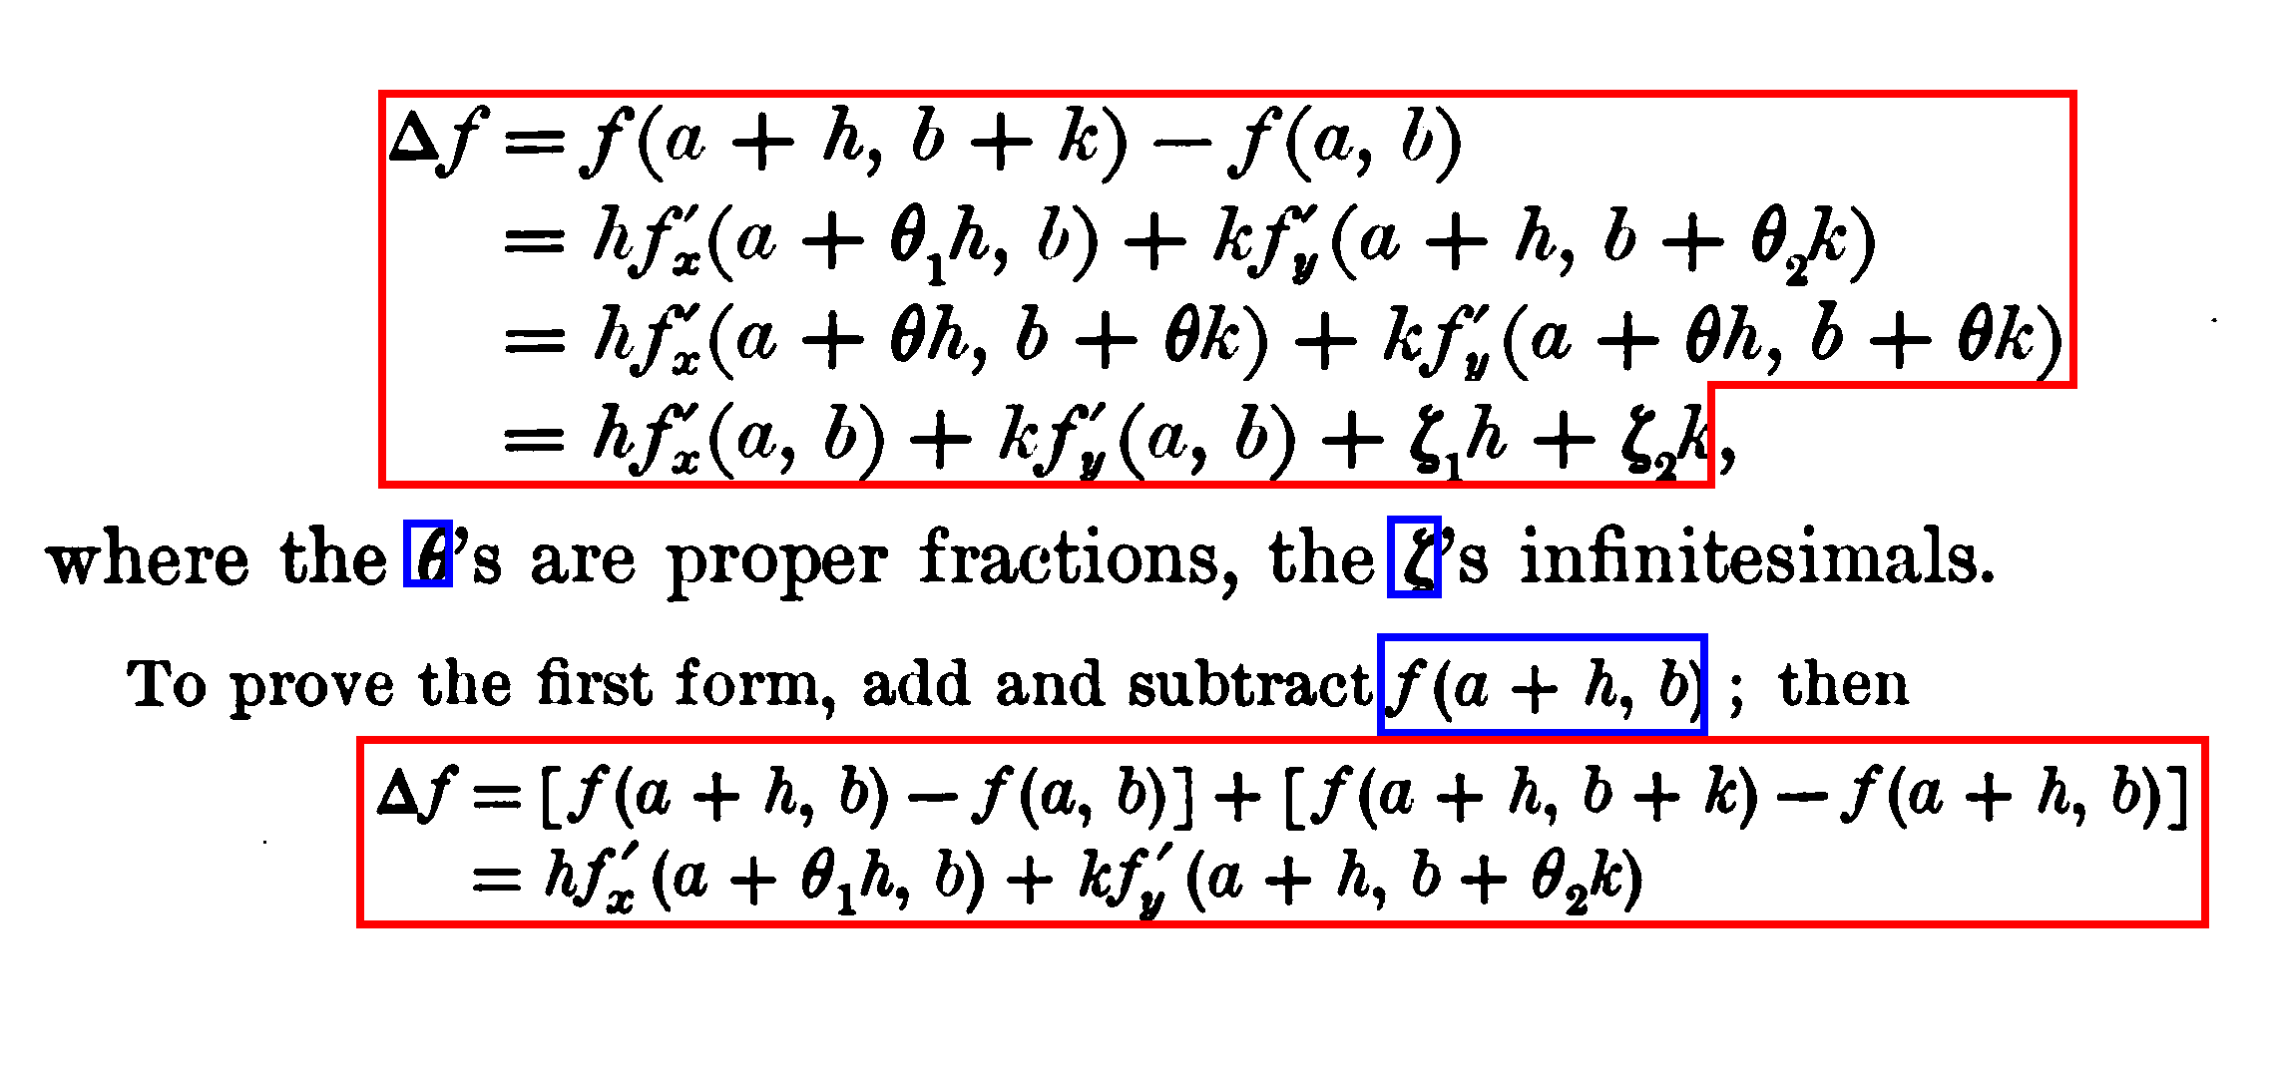
^^ Will cite extending segmentations in the groundtruth to include isothetic ones where necessary as future work!!!!!!!!!!!!!!!!!!!!!!!!!!!!!

- Any expression which is not part of a normal text line is considered displayed

Displayed expressions are also expressions that may be embedded in an image or table (embedded expressions are herein defined to be those which specifically are embedded in text only)

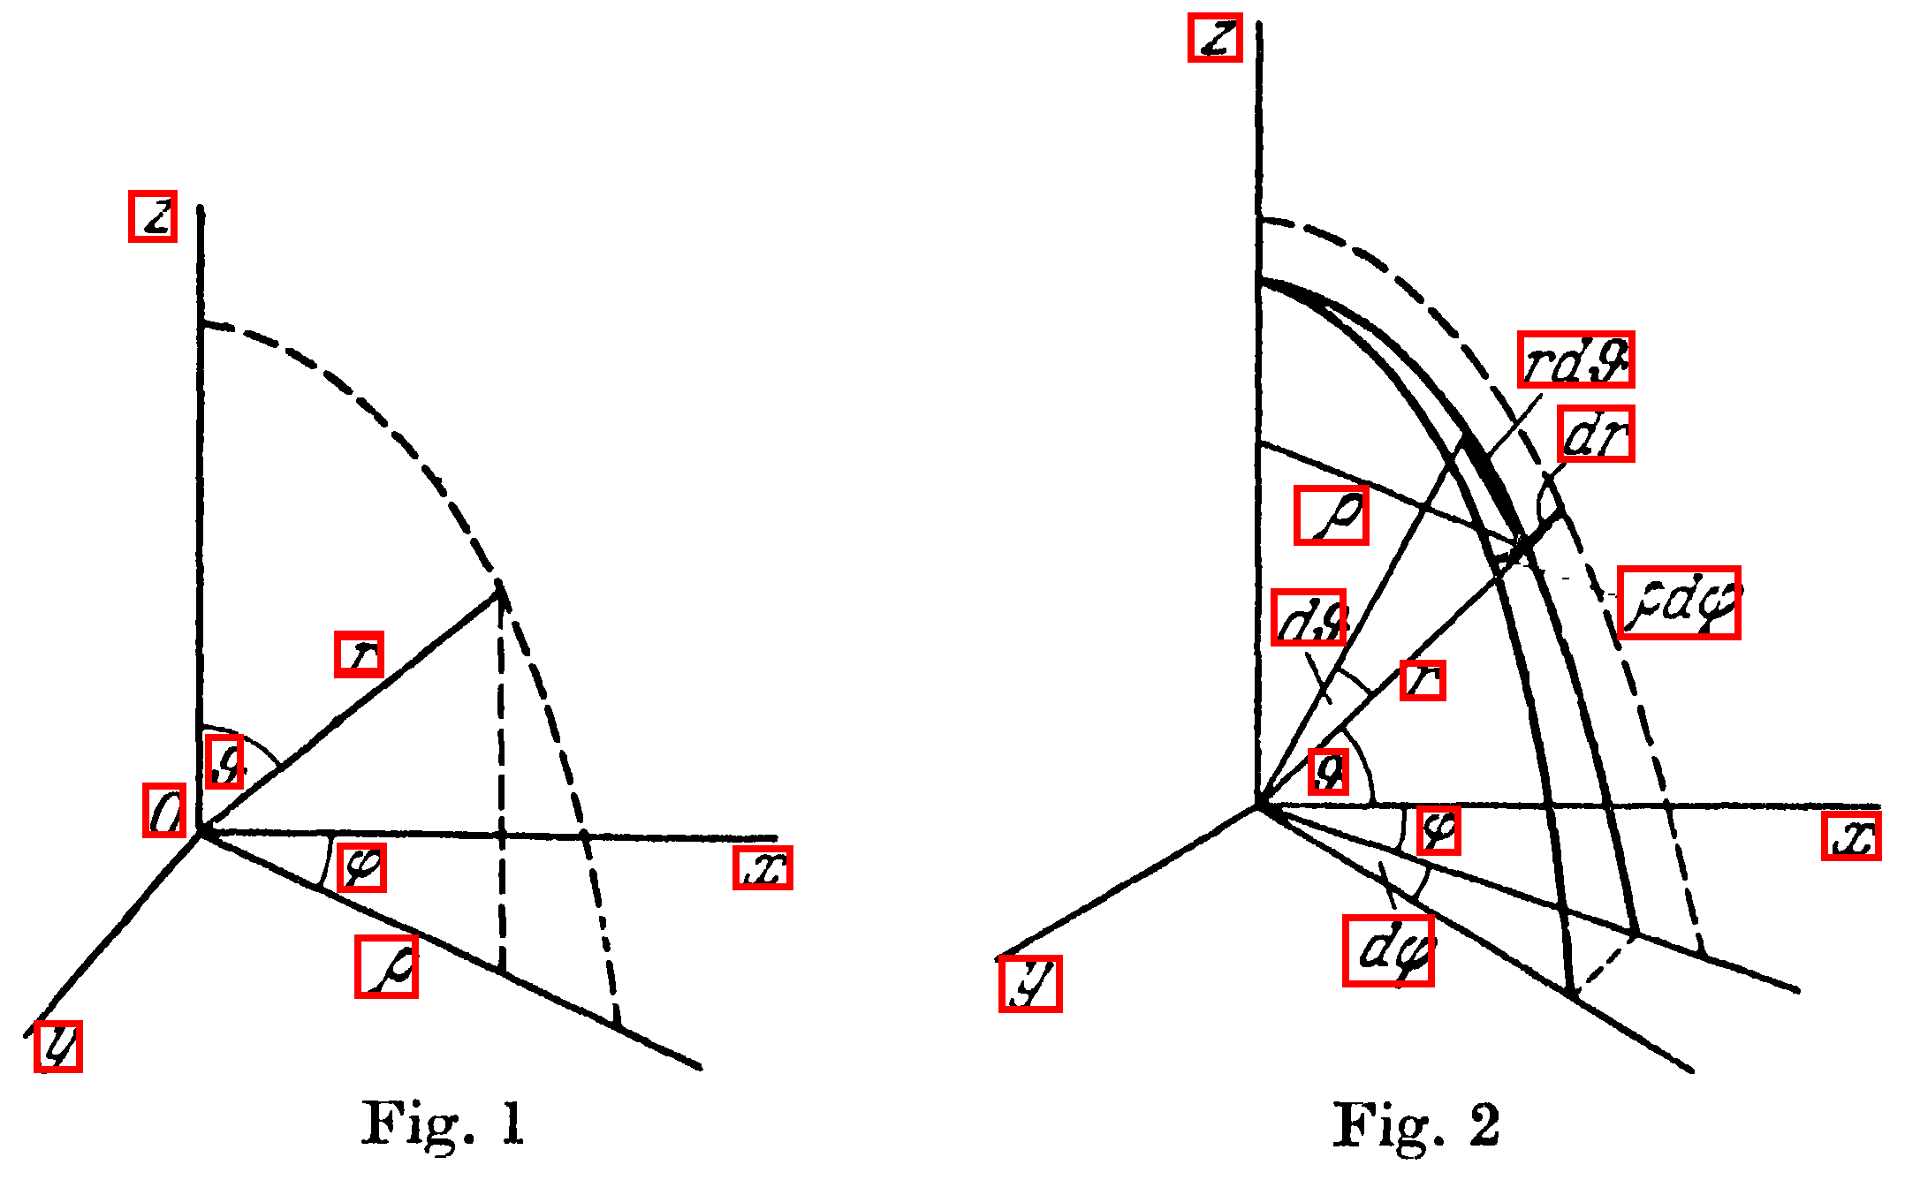

- Expressions separated by commas are only joined as a single segment if there is an ellipsis. ..^^ comma separated lists of expressions are merged into one expression when they include an ellipsis since syntax can be interpreted mathematically as a series. When lists of expressions do not include an ellipsis they are not merged and the commas are interpreted as part of the sentence wherein the expressions are embedded as opposed to being part of the expression which would be functionally incorrect.

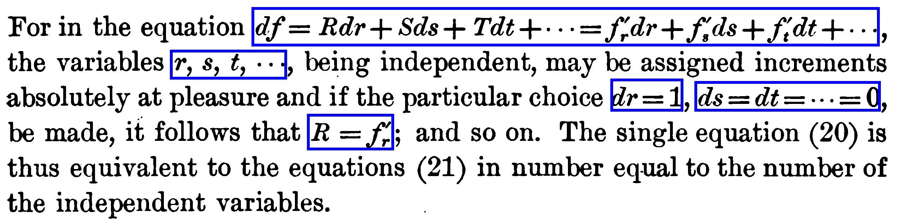

Future work and questions this work will not address:
- Update groundtruth to handle isothetic blocks and not just rectangles
- How should single expressions which extend from the end of a text line to the begginning of the next one be segmented appropriately (an idea is to logically connect the segments somehow even though they are not physically connected)

The design starts in a bottom up fashion and makes no assumptions about how column partitions were made prior to it's instantiation. The module does, however, utilize the results of language-specific OCR (while the default language is English, other languages may also be employed) in order to quickly rule out most normal regions of text from possibly being mathematically oriented. The hope in the design of this module is that it will still work all the same even if the underlying Tesseract framework from which it is instantiated were to be altered.

The input to the MEDS module is a grid of column partition objects (Colpartitions) and the CPset determined by the hybrid layout analysis technique described in [hybrid article]. The grid template container class is used within the Tesseract framework for fast neighborhood access to bounding box classes as illustrated in Figure ____. The grid provided to the MEDS module has, as its contained object ColPartition objects determined through the previous hybrid layout analysis [refer to article]. Since one of the design goals for this module is to ensure the MEDS results are as independent of previous hybrid layout analysis as possible, the ColPartitionGrid is first converted to a BlobGrid. While the ColPartitionGrid allows for nearest neighbor access among the column partitions, the BlobGrid allows for nearest neighbor access among all of the connected components in the image.

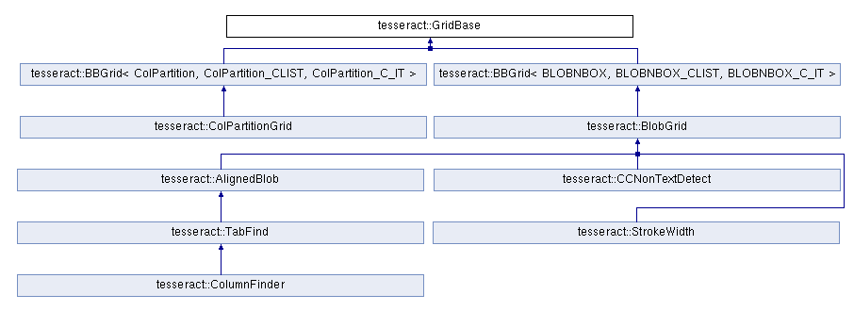Illustration 3: TODO: Brief explanation of the gridbase datastructure and it's importance within the Tesseract framework.

While the BlobGrid is desirable for proper understanding of mathematical expression regions, it contains no understanding of normal text regions. Easily recognizable symbols which consist of multiple connected components (i.e. “i” and “=”) are kept as separate blobs within the grid. Running tesseract's language specific OCR on these separated symbols proved to be largely innaccurate. For instance an “=” symbol run through Tesseract's character recognizer would consist of a recognition being made for each horizontal line in the “=”. Surprisingly, the individual horizontal lines were not recognized as dashes but instead as “j”. Similar problems were observed on various other characters. For instance a “.” which was often mis-recognized as an “o”. In order to mitigate such problems, a new GridBase data structure was implemented in this work, which contains a combination of the information in the BlobGrid and information attained from running OCR on each previously determined column partition on the page. The grid's objects contain information on both the symbols which were recognized during OCR and those which were not. If information is available from OCR for a given symbol, then the recognized word to which the symbol belongs as well as its confidence rating are stored within the object. The object also contains the symbol's bounding box and the sentence to which it belongs (if applicable). Since, during the recognition stage, some blobs may be improperly merged into symbols, a second pass is made by the MEDS module in order to detect all blobs belonging to invalid words, and improperly merged blobs are thus split into separate objects in order to facilitate proper analysis of potential mathematical expression regions (illustrated in Figure___).

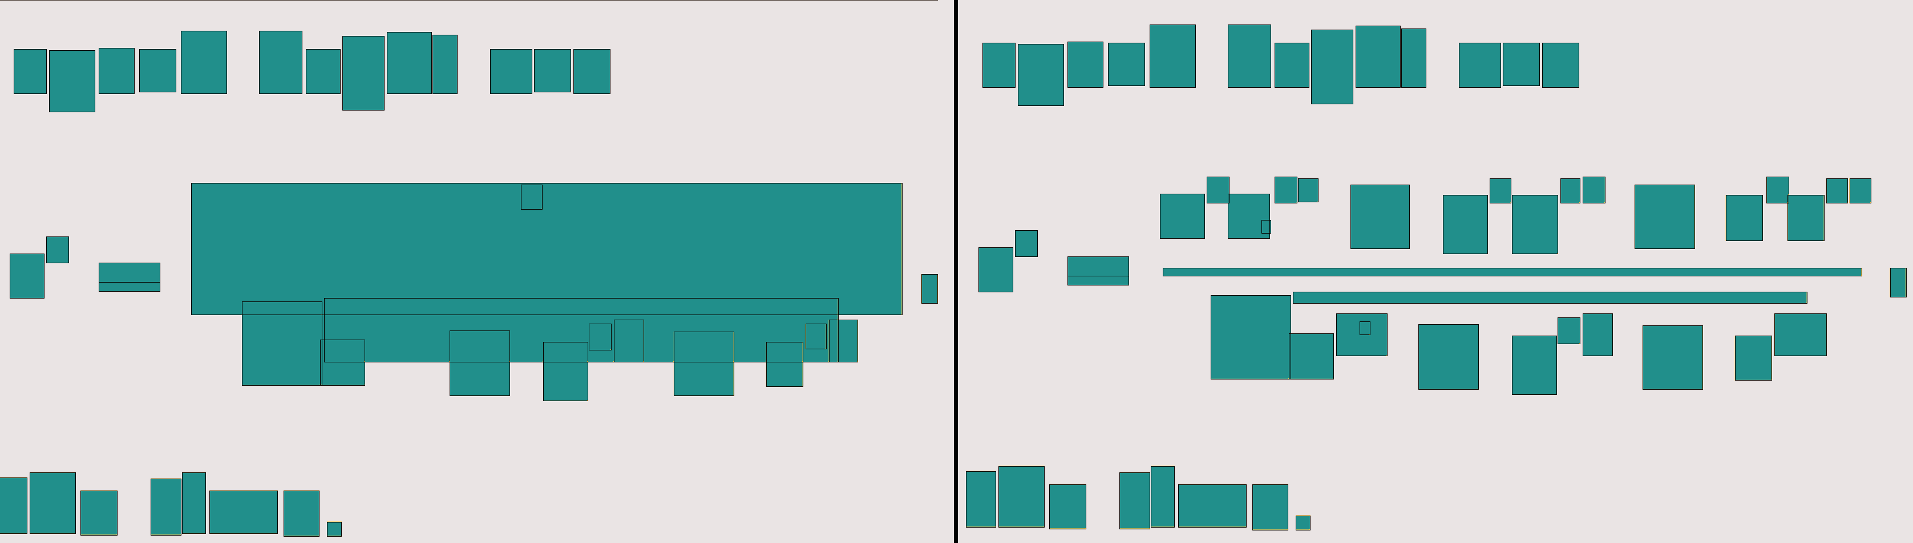Illustration 4 Both the left and right images correspond to the same mathematical expression region. The left image shows the symbols remaining after OCR. Notice that many of the symbols were ruled out as junk. On the right is the same expression region after the MEDS module noticed that the blobs in the region did not belong to valid words, split them back up, and reinserted them into the grid for proper analysis.

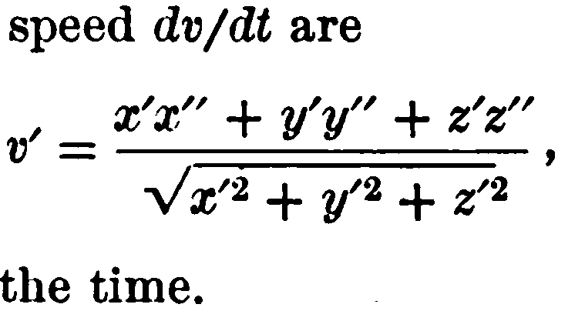Illustration 5: The image corresponding to the expression illsutrated by Figure ___

The new grid data structure, called the BlobInfoGrid, which as previously described, holds a combination of information obtained from OCR and information available from a grid of all connected components on the page, is used as input to all subsequent feature extraction, classification, and segmentation techniques.

High-level overview: #TODO convert this into a flowchart....
1) Use the trained classifier to detect seed regions for expressions
2) Merges the seed regions with their surroundings using various heuristics
3) Looks for remaining non-language symbols within the merged regions to find any previously missed seeds and repeat step 2 to merge properly based on heuristics. Repeat until no unmerged seeds remaining.
4) Look for labels to displayed expressions.

Detection Module (stage 1)

The detection module utilizes a supervised machine learning approach in order to predict which non-noise connected components on a page are most likely to belong with printed mathematical expressions. Detected regions are considered as the initial seeds to mathematical expression segmentation carried out in the second stage. The primary motivation is, not necessarily to maximize detection accuracy on the groundtruth data set, but rather to allow for generalized prediction accuracy on unforeseen pages. While perfect accuracy is not expected, it is important that at least a single component for each mathematical expression zone is detected at this stage since these components may then be merged with their nearest neighbors in a later step for proper segmentation. Thus, for regions wherein a single component has already been detected, false negatives are most often of very little importance. False positives, however, will be difficult to account for in later stages without harming MEDS accuracy. The goal of the detection step is thus to detect at least a single connected component of each expression zone while minimizing false positives to the greatest extent possible. The remainder of each detected zone can then be combined with its neighbors using various heuristics during the segmentation stage of the MEDS module. While regions that may have been missed during this process can potentially be corrected in later steps, false positive recognition likely will be uncorrectable.

There are two separate components to the detection module: (1) training and (2) prediction. The training step extracts chosen features from a small subset of the groundtruth, runs and evaluates the binary classifier on these features multiple times in order to learn classifier and feature specific parameters. These parameters are then later used by the classifier to make decisions about unforeseen data during prediction. Accuracy is evaluated by testing the prediction accuracy on the non-training subset the groundtruth dataset after training (this is the majority of the data set), and then subsequently evaluated through visual inspection on random unforeseen data which is completely unrelated to the groundtruth.

Training:

Cross validation – A labeled training set is randomly divided into m disjoint sets of equal size n/m, where n is the total number of labels in the training set. The classifier is trained m times, each time with a different set held out as a validation set. The average the m validation errors is considered as the classifier's performance. By adjusting parameters so as to minimize this error, it is hoped that the classifier's accuracy will generalize better to new data.

Jackknife – Train the classifier n times (n is the total number of labels in the set), each time using the entire training set from which a different single training point has been deleted. Each resulting trained classifier is then tested on the single deleted point and overall accuracy is estimated as the mean of all test results. Jackknife is especially good for comparing two classifiers, to see if the difference in accuracy between them is statistically significant.

Bootstrap – Samples (of any size less than that of the training set) are randomly pulled from the labeled training set with replacement (i.e. the same label may be used multiple times). The classifier is trained on all of the samples and tested on the others. The average of all of the accuracies is measured. Classifier parameters can be adjusted during training in order to minimize the average error.

Bootstrap with Aggregation (Bagging) – Results of multiple classifiers trained on the bootstrap dataset are pooled together in some fashion to get the final result. The multiple classifiers are typically all the same type (i.e. SVM, neural net, decision tree, etc) but have different parameters due to being trained on different sets. The results of all of the classifiers are typically combined through a voting mechanism.

Boosting – Multiple weak learners (classifiers with accuracy only slightly better than chance) are combined in order to achieve arbitrarily high accuracy on the training set. A subset of labels of some size less than the total number of labels is randomly selected without replacement and the first classifier is trained on this subset. A second training set is then selected so that half of the patterns in it are correctly classified by the first classisifer then half are incorrectly classified by it. Boosting techniques vary based upon how this second and subsequent training subsets are chosen. An example boosting technique in order to train three classifiers described in Duda and Hart's “Pattern Classification” textbook involves flipping a fair coin to decide between the following:
(1) Select remaining labels from the dataset (not in the already extracted subset) presenting them one by one to the existing classifier until it misclassifies one of them. The misclassified label is added to the new subset.
(2) Add a pattern that the first classifier classifies correctly
This is continued until no more patterns can be added in this manner. Thus half of the patterns in the new subset are correctly classified by the first classifier and the other half are not. The second classifier is then trained on this new dataset. A third dataset is then found by presenting remaining labels (not in either of the first two sets) to the first two classifiers. If the two classifiers disagree, then the label is added to the third dataset, otherwise it is ignored. Finally the third classifier is trained on the third dataset.

Adaptive Boosting (AdaBoost) – Each label receives a weight that determines its probablitiy of being selected for a training set for an individual classifier. If a label is accurately classified, then its chance of being used again in subsequent classifiers is reduced, while if it is not accurately classified its chance of being used again is raised. The algorithm starts by assigning a uniform weight to each label in the training set. On each iteration a subset is drawn according to the weights (initially at random since they are uniform) and a classifier is trained on the subset. Next the weights of misclassified labels are increased and correctly classified label weights are decreased. Labels chosen based upon these new weights are then used to train the next classifier and the process is repeated until the desired number of classifiers are trained. During prediction, the weighted output of all classifiers are combined and the final classifier decision is made using the sigmoid function on this summed output.

Training Process::
assigning labels to all blobs in the grid (page) based on groundtruth file ::: illustration below (make a not of some of hte imperfections that occur (why does this happen with the “g” in the image below????)
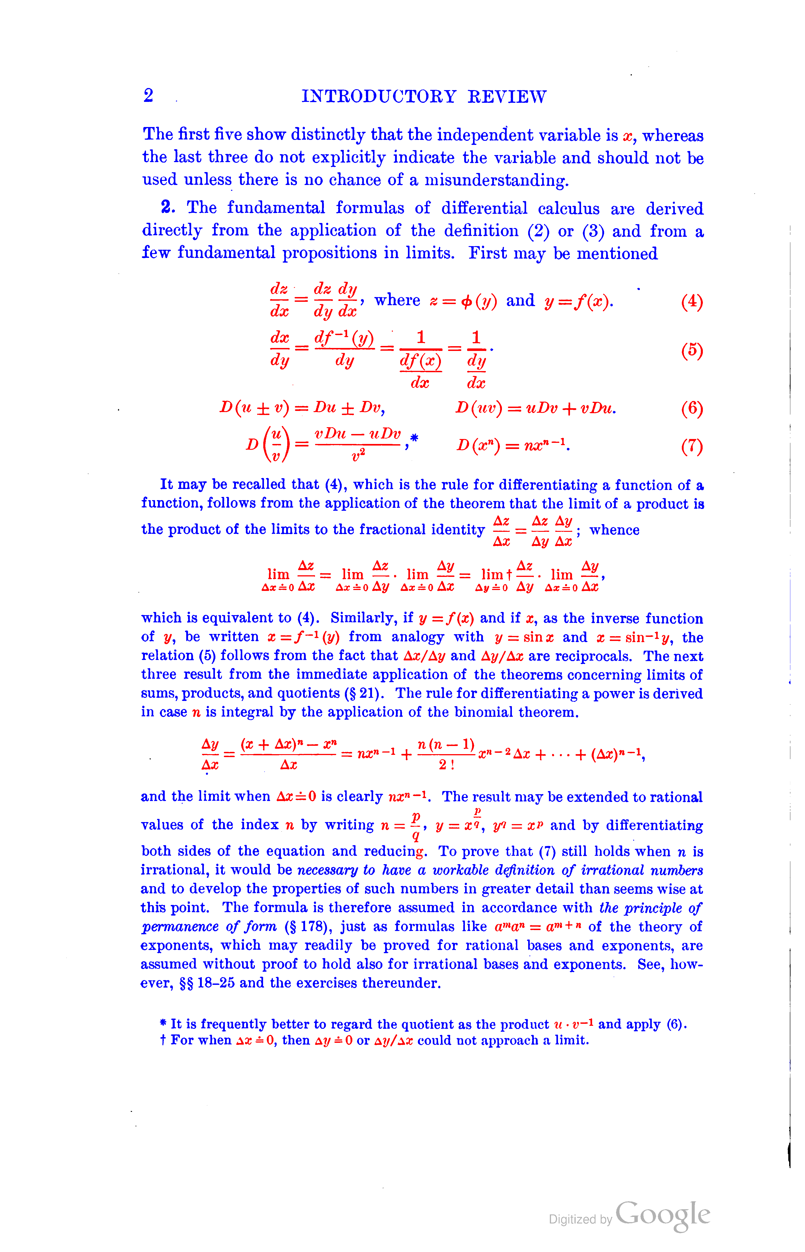

Done: Need to review how the blobs are assigned to sentence.... not sure why exactly it screws up so often...... need a clear explanation to document it in the thesis either as goal for future work (or if its easily fixable just fix it now!!) < Many bugs were resolved by assigning the word index and line index to blobs based upon the OCR page results data structure. Remaining bugs occur when the expected word index of a blob based on spacing of characters in OCR results differs from the word index assigned by the page results data structure. It is difficult to fix this error because the precise mapping of each blob to where it's OCR result resides in a sentence is not stored anywhere by Tesseract.

Illustration::::::: (alternate between coloring sentences red, green, and blue and save the pages.. find a good one for illustration purposes)

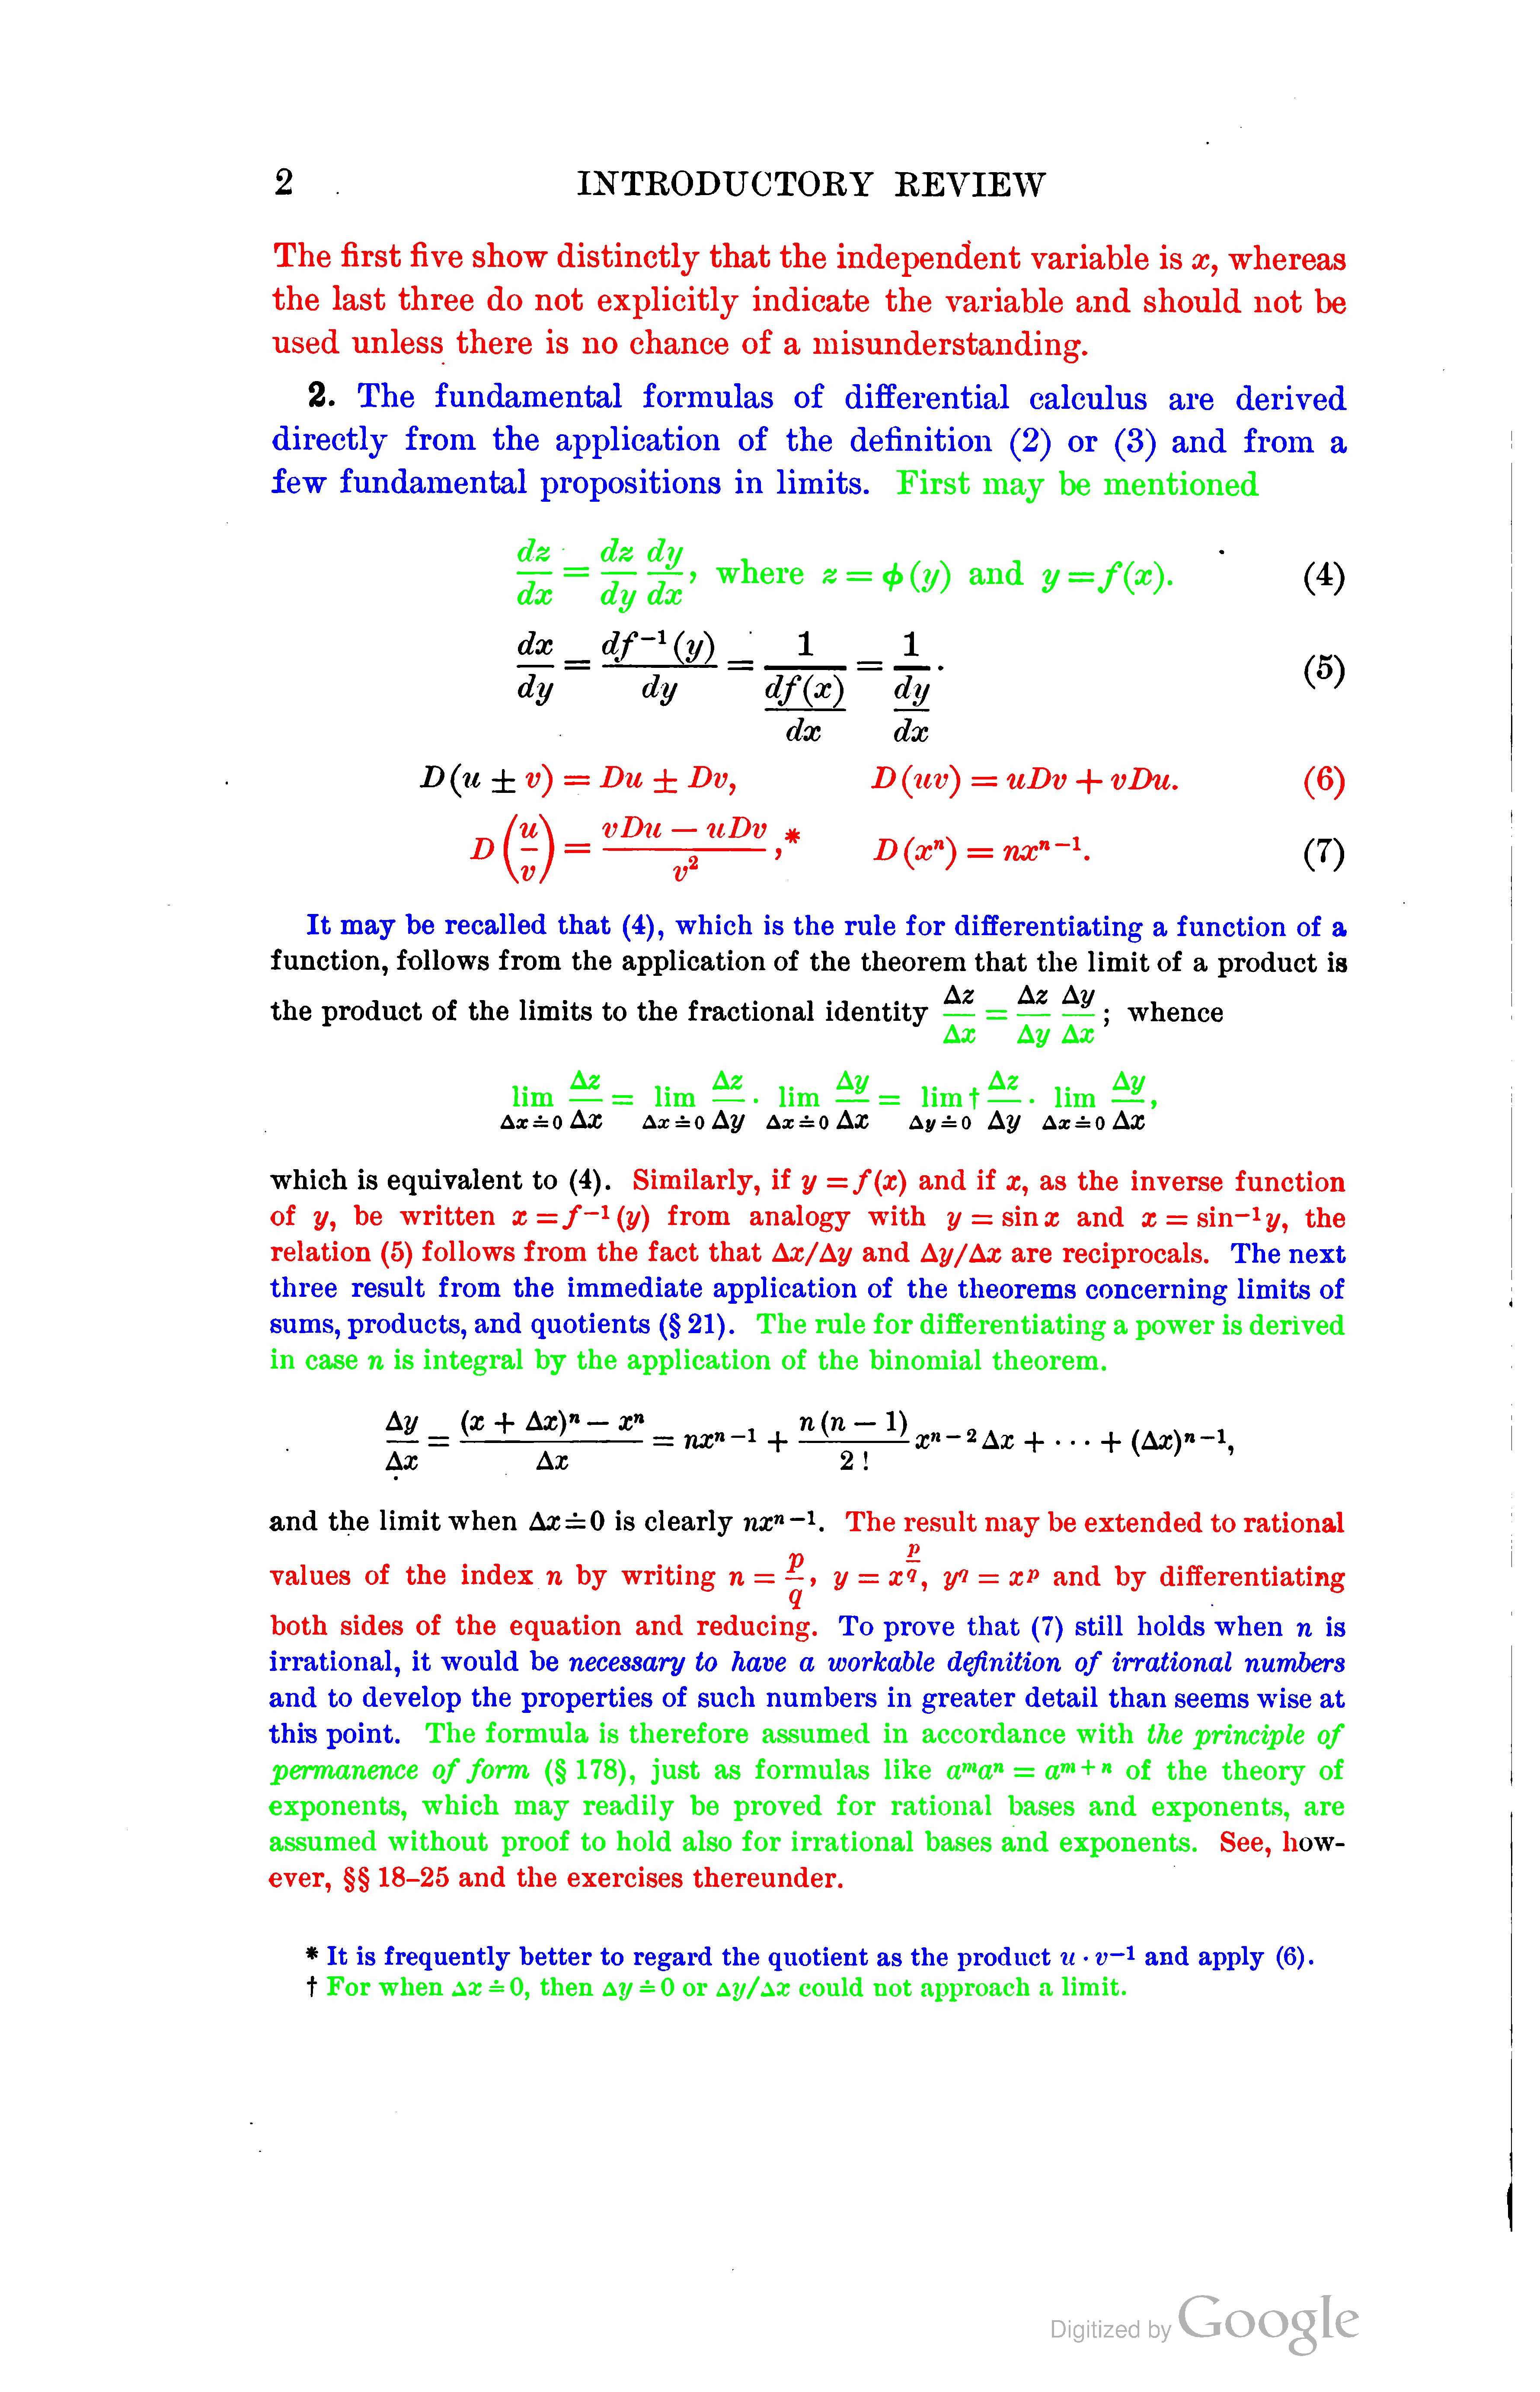

^^ List of sentences:
0: The ﬁrst ﬁve show distinctly that the independent variable is x, whereas
the last three do not explicitly indicate the variable and should not be
used unless there is no chance of a misunderstanding.

----------------------------------

1: The fundamental formulas of diiferential calculus are derived
directly from the application of the deﬁnition (2) or (3) and from a
few fundamental propositions in limits.

----------------------------------

2: First may be mentioned
dz ‘_ dz dy
g = g 3%: where z = ¢(g/) and y-_=f(:c).

----------------------------------

3: Du :1; Dv,
D (em) = um + vDu- (6)
D — D

De): v__u_;}2;J,=v« D(:,,,.

----------------------------------

4: It may be recalled that (4), which is the rule for differentiating a function of a.

----------------------------------

5: Ax _ A31 A9:
lim ::1iIIl 1- lim Z_—_1im’r"'—"-lim ‘-1’-,
Az ‘I2.

----------------------------------

6: Similarly, if y = f (as) and if as, as the inverse function
of y, be written a:=f-1(y) from analogy with y zsina: and a:=sin-13/, the
relation (5) follows from the fact that A2:/Ay and Ay/A3: are reciprocals.

----------------------------------

7: The next
three result from the immediate application of the theorems concerning limits of

sums, products, and quotients (§ 21).

----------------------------------

8: The rule for differentiating a power is derived
in case n is integral by the application of the binomial theorem.

----------------------------------

9: The result may be extended to rational
P
P
values of the index n by Writing n = -15, y = 9:3, 3/1 = 9:19 and by differentiating
Q
both sides of the equation and reducing.

----------------------------------

10: To prove that (7) still holds ‘when n is
irrational, it would be necessary to have a workable deﬁnition of irrational numbers
and to develop the properties of such numbers in greater detail than seems wise at
this point.

----------------------------------

11: The formula is therefore assumed in accordance with the principle of
permanence of form (§ 178), just as formulas like ama" = a"'+" of the theory of
exponents, which may readily be proved for rational bases and exponents, are
assumed without proof to hold also for irrational bases and exponents.

----------------------------------

12: See, how-
ever, §§ 18-25 and the exercises thereunder.

----------------------------------

13: It is frequently better to regard the quotient as the product u - v-1 and apply (6).

----------------------------------

14: For when Ax é 0, then Ay é 0 or Ag//A9: could not approach a limit.

----------------------------------

^^TODO: Reduce this to a subset that fits in one illustration!!!!!!!!!!!!!!!!!!!!!!!!!!!!!!

Training Data Selection:
1. Choose the training set: This will be 15 pages of data (the entire data set is only 75 pages long...). Thus I will use 15 pages of this textbook for training and the other 60 for testing. The 15 pages are taken from one text book which is different from 45 pages of the others to observe the generalization accuracy of the system.

Data available:
1. 30 pages advanced calculus
2. 15 pages digital calc
3. 15 pages physics
4. 15 pages dynamics

15 pages of the advanced calculus will be used for training.

Since there is still 15 pages in the test set which is from the exact same text book as the training data. Tests will be carried out with and without the remaining advanced calculus data to observed any overtraining issues. If the system does considerably better on the other 15 pages from the same text book then overtraining may be a concern.

TODO::: consider using a smaller number than 15 for training, Perhaps 8 would be a good number???!!

TODO:: implement n-gram feature extraction
I'll start with using 15 pages for training, but may try other configurations once the implementation is taken care of.

TODO:: Describe n-gram ranking for 15 pages, how it was done, and results

TODO:: Import everything here into the thesis and organize it

7. Review some of Garrains work to figure out where to go from here (but try and knock this thing out as fast possible so by no means should you try and make things perfect!!!!)

  - Linguistic Analysis: Use of n-grams to locate expressions embedded within text (see chapter x.x). N-gram: assigns a probability to each blob of being mathematical based upon the sentence to which it belongs. Each sentence is assigned a probability of containing an embedded or displayed expression. A sentence is here defined as a string of words starting with a capital letter, valid first word, and ending with a period.
    - Each blob is assigned a sentence
    - Each sentence is assigned a probability of containing mathematically oriented text based upon bi-grams...
    - Garain ---- 2005 article: A corpus for OCR research on mathematical expressions.

N-gram profiles are created for each word as follows:
1. Digits, punction marks, and any other non-word text is discarded so that only words are presented.
2. Each sentence is scanned to generate all distinct word-level n-grams where n is 1-3. The frequency of each n-gram is recorded.
3. Relative frequency of each n-gram is computed relative to the other n-grams with the same value of n.
4. Sort all of the n-grams based upon their frequencies.

What I will do is as follows:

For the training data I'll do n-gram frequency counts where n is 1-3, grouped by their n, and ranked into decreasing frequency order. This set of data only contains those falling under the category of mathematical sentences (i.e. sentences which contain some form of math). A sentence is deemed as a mathematical one if any of the blobs contained in that sentence are within the bounds of a mathematical expression in the groundtruth.

I'll record the results with some cutoff point for frequencies to be empirically determined.

Also do n-grams for non-math sentences. Then subtract the frequency of the non-math n-grams which appear on the math one, so that n-grams which appear in either are not weighted too highly.

The n-grams deemed to be important will then be used as features. If a sentence contains one of the n-grams for expressions then it's feature will reflect that based upon the importance which that n-gram was observed to have during training.

I'll use the same set of training data that I'll be doing all my training on.

Set up everything, all the interfaces, etc....

Briefly also mention the other

Design emphasizes ease of interchanging feature extraction methods...

Using compile-time polymorphism

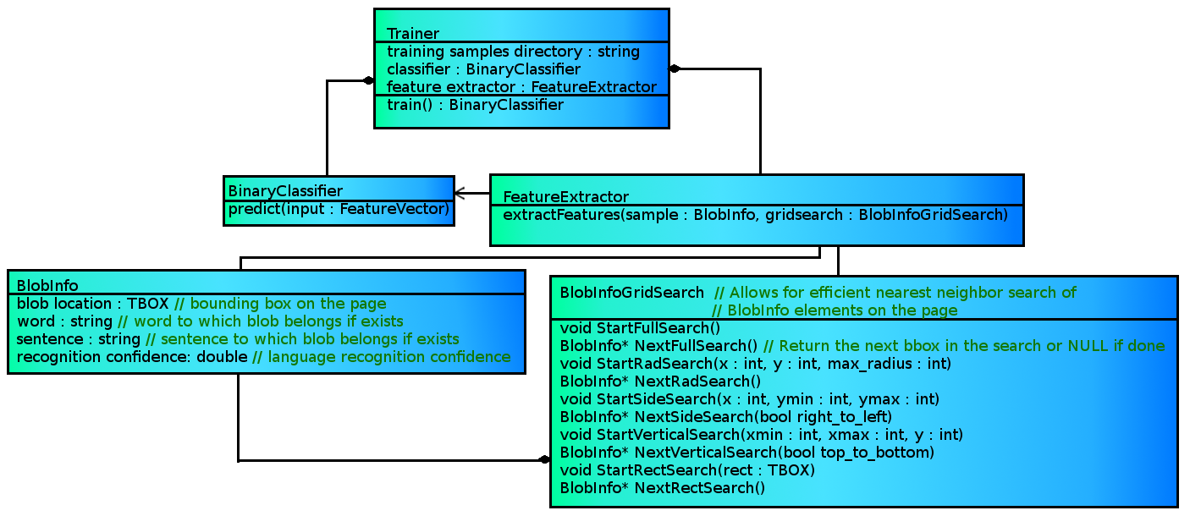Illustration 6: UML diagram to depict the trainer, classifier, and feature extractor interfaces used in the detection module (and also the data BlobInfoGrid data from which features are extracted). Compile-time polymorphism is utilized in order to facilitate experimentation with and comparison of various combinations of training, classification and feature extraction.

Trainer: Takes a feature extractor/binary classifier pair and a set of samples. Trains the former on the latter. The set of samples is simply a string which specifies the directory wherin the samples are located...

So this will be a template with the extractor/classifier pair.

Simply has a training method. The output of the training method is the resulting trained binary classifier. The training method is purely virtual.

FeatureExtractor – carries out some form of feature extraction to return a variable sized vector of doubles

Features to extract:

- Recognition of the following combination of features on math detection:
  - Measurement of the number of horizontally adjacent characters to the right of a given character within some vertical threshold (see chapter x.x).
  - Sub-script/super-script recognition
  - Linguistic Analysis (see above....)

  - Testing whether or not a character's language classification result falls under a category of potential math symbols such as <,>,_,+,-,/,%, etc.
  - Vertical distance to nearest character neighbor above and below (within a horizontal threshold), horizontal distance to nearest neighbor left and right (within some vertical threshold).
  - Ratio of horizontal and vertical distance from nearest neighbor to the left and above to nearest neighbor to the right and below respectively. ????
  - Height of characters as compared to average character height within a page
  - Detection of Italicized text
  - Horizontal bar detection
  - Features extracted from PDF if available
  - Detection of indentation or centering of text
  - Measurement of character vertical distance from a row of text's baseline

Note:
Some instances were observed wherein an entire expression region was completely discarded as noise by Tesseract's framework.

^ observed in image 9 (the zero is discarded as noise by the Tesseract framework prior to any mathematical analysis

Training has revealed that there are some instances where, when an image region is not properly segmented from normal text prior to recognition, the recognition results as well as the bounding boxes corresponding to the normal text is corrupted.. (show image to illustrate this,,, can be seen in image 10 where part of an image is erroniously merged with a column partition prior to being input into the mathematical detection module, when recognition is carried out on this region the bounding boxes are somehow corrupted...... this could be something i could fix, but i may leave it as future work....)

^ Resolving such issues woudl require tweaking the framework external to the MEDS module which, for now, is outside of the scope of this work. Goal for future work would be thus to tweak Tesseract's external framework to be less harsh on discarding percieved noise prior to running any math detection/segmentation modules.

Note:
The algorithm which assigns sentences to blobs does well, however is not perfect. Problems with this stem from not knowing exactly where all of the recognition results physically are, since these are not physically stored in memory by Tesseract for optimization purposes. Although the word corresponding to the recognized blob is stored by Tesseract, the line on which the blob resides is not. A text line is thus first assigned to each blob by analyzing the recognition results of each column partition which has previously been segmented by Tesseract. If a column partition has more than one line of recognition results then the left-most character if each line is detected by doing horizontal and vertical searches on the grid. Once the left most characters have been found, a left to right search is carried out on each character vertically overlapping the left-most one to assign all of the blobs which are horizontally aligned with it to the left-most characters' line. Once each blob is assigned a line, the start and end of each sentence within every line is detected. A start point is considered as any valid word starting with an uppercase letter, while an end to a sentence is simply considered as a period. All of the blobs on the grid are then each assigned a sentence in turn based upon comparing the index of the word to which they belong in relation to their text line to either the starting point of a sentence for the given line, the end point of a sentence for the given line, or, if the blob is in between the start and end line of a sentence then simply the text line on which it resides. In order to test the accuracy of the sentence assignment module, Tesseract's ScrollView event handler was overridden so that, when a blob is clicked on, it's assigned sentence is displayed. The accuracy is often highly favorable, however there observed some cases wherein a blob which is actually a couple of words left of the start of a sentence is wrongly assigned that sentence.

SVM discussion:
For svm, figure out what I'll be using::

http://research.microsoft.com/en-us/um/people/manik/projects/trade-off/svm.html
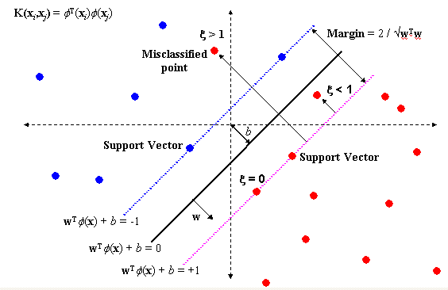

Using the soft-margin, C formulation of the classifier. Where C is a variable specifying

with Chu's training technique (libSVM) http://www.csie.ntu.edu.tw/~cjlin/libsvm/

using radial basis function (gaussian) as the kernel which maps the feature space to a higher dimensional one wherein the classification is carried out.

(don't forget to reference the original vapnik article from '95)

Non-linear

refer to idiot's guide to svms and also the practical guide!!!!!!

Binary Classifier – does a binary classification on the result of the given feature extractor, is trained by whatever training technique is employed by the trainer which uses it. Once trained, the classifier can carry out a prediction on new data assuming the input data is a feature vector of the correct size.

Samples??? <<< directory which contains the images and groundtruth on which the training will take place...... this is jsut a string.. the trainer abstract class will hold a method to grab these samples from the directory

#TODO:
Look into SVM, include brief description of how it works fundamentally.. I'll be using the basic rbf kernel but need to review what all this is.. look at previous work, etc.....

High level view of the prediction:
Iterate through each symbol in the image that has not already been discarded as noise and for each one do the following:

- Feature Extraction Interface, extract variable number of features. Results in a vector of doubles (each normalized between 0 and 1) – will talk about this after discussing the machine learning stuff

- Binary Classifier Interface: Takes the resulting feature vector from the extraction interface and makes the decision as to whether the bounding box is a math candidate or not. This classifier is assumed to already be trained for the given feature vector at this point.

The feature extractor and binary classifier are inherently tied together. If the binary classifier is changed the feature extractor must be changed too.

#TODO look into generalization error... read up on these things in the text.. very important!

Prediction:

}

initial expression bb's will be found based upon a variety of features:
n-grams: take each sentence and append it to a list. Iterate the list, calculating a likelihood that the sentence contains an embedded expressions. Each bounding box gets a feature aligned with its sentence's n-gram feature....

, italics,
single italic/bold letters among normal text likely to be variables!! but when are they not?? any NOT examples???

Features I considered way back when:
Recognition of the following combination of features on equation detection.
Although many of these features have indeed been studied to some extent,
they have yet to all be used within a single framework as of this date to the
author's knowledge.
◦ (*) Measurement of the number of horizontally adjacent characters to the right of a
given character within some vertical threshold (see chapter x.x).
◦
Sub-script/super-script recognition
◦ (*) Running a Tesseract classifier trained using Infty Reader's database of
mathematical expressions and comparing the result to normal language output to
detect math expressions (possibly subsequent recognition?) (see chapter x.x)
◦ Use of n-grams to locate expressions embedded within text (see chapter x.x)
◦
Testing whether or not a character's language 2 classification result falls
under a category of potential math symbols such as <,>,_,+,-,/,%, etc.
◦
Vertical distance to nearest character neighbor above and below (within a
horizontal threshold), horizontal distance to nearest neighbor left and right
(within some vertical threshold).
◦ Ratio of horizontal and vertical distance from nearest neighbor to the left and above
to nearest neighbor to the right and below respectively. ????
◦ Height of characters as compared to average character height within a page
◦ Detection of Italicized text
◦ Horizontal bar detection
◦ Features extracted from PDF if available
Detection of indentation or centering of text
◦ Measurement of character vertical distance from a row of text's baseline

Only some separators, however end up being part of an expression. Final decision is made during the segmentation pass. Separator candidates are searched for in both bounding boxes that were labeled as expressions in the first pass and those which were not. Candidates determined to be false positives are put back to whatever status they were in before (i.e. either math or non-math).

2. Segmentation
These located bounding boxes are then merged into partitions, each of which should correspond to a single mathematical expression. This is also where it is decided whether an expression is displayed or embedded.

This step does not include a classifier and relies upon various heuristics and unsupervised learning in order to make the appropriate decisions. Adaptive learning comes into play when information on the spacing of mathematical symbols in expressions can be assertained from observing size and space ratios found in a limited number of known heuristics on the page. The expected horizontal/vertical distance between an operator and operand may, for instance, be a useful parameter while merging. Once such parameters are learned correctly for the page in question it is expected that fewer mistakes will be made for initial guesses, and thus efficiency increased for the segmentation of subsequent zones on the page.

When an ellipsis is detected any list of expressions separated by commas is merged into a single expression.

Separators
Separators like “,”, “.”, “if”, “and”, “whence”, “then”, “denoting”, “thus”, “therefore”, etc. are detected as non-math during the merging process and used as a factor in deciding when a merge is complete. Various separators are often used to delimit displayed mathematical expressions. While separators which delimit embedded expressions typically carry the same functionality as they would in normal sentence structure, separators which delimit displayed expressions are observed to, at some times, deviate from this pattern as demonstrated in Figure ____.

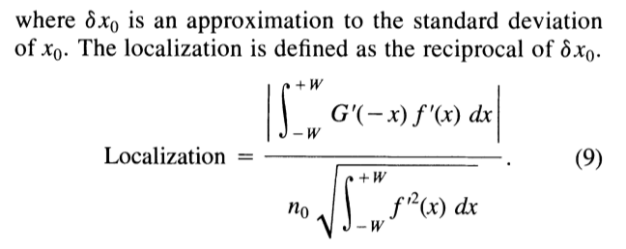

taken from John Canny's well-known 1986 IEEE paper on edge detection . Notice that the period in the above expression serves no functional purpose.

The period or comma seen just outside of a displayed expression, although sometimes useless with regard to the surrounding sentence structure (and in some cases missing altogether) can be functionally useful to delimit multiple expressions. Words like “when”, “with”, “therefore”, etc. may also be observed to delimit expression regions either on separate lines or on the same line. For mathematical recognition purposes it is very important that these separate regions are segmented properly. If more than one expression or part of an expression are fed into a mathematical recognition module, unpredictable and erroneous behavior will likely be observed.

Merging Rules/Heuristics:

1. if the current or neighboring connected component has been recognized as one of the following mathematical (or potentially mathematical) operators:

“+”, “)”, “(“, “[“, “]”, “*”, “!”, “<”, “>”, “/” [[[cross/dot product??]]

dot product is being recognized as “o” by the english recognizer too big for a period... and dot product symbol hasn't been included in training...

as it stands right now, equals signs are not being recognized, since i'm recognizing things on a blob by blob basis.

“+” is good....

“-” not being recognized (thinks its a j...)

“,” was mistaken for “:”.... wtf

cross product recognized as “x”

“/” was well recognized

.... periods aren't being recognized either....

“I”, “i”, “l” is often mistaken for “1”

#TODO check how well bold and italics are recognized on the page also!!!!!!!!!!!

confidence closer to 0 is better..... confidences down to as low or lower than -5 are observed to be correct in some cases, but also often incorrect. Also really high confidences can sometimes be in correct like -2... if its less than -10 that's definitely a red flag...

..idea:: maybe i could run a really quick image analysis to detect periods, commas, and horizontal bars, exclamations, dotted i's.

The OCR result on individual blobs is pretty good for letters, but for other things, not so much..... really needs to be taken with a grain of salt....... It is not very reliable.. the strenght of tesseract is not in its classification of individual blobs, but ability to understand english words and sentence structures, and adaptively improve classification of individual blobs based upon information gleaned from word and sentence understanding. I will not be utilizing Tesseract's word segmentation for my purposes so this will not be very useful for me.

while tesseract has been trained for math recognition, no information on how this training was carried out or on what dataset was provided. The math symbol recognizer thus was not re-used in this work since the system is designed to work indepently of any specific implementation provided with Tesseract (outside of the basic data structures for bounding boxes and grid search).... It was decided that the learning curve to teach myself how to train the system for expression detection would be outside of the scope for this work, and is left as a goal for future work.

3. Iterative missed region segmentation
Using new information on what symbols are most likely to be mathematical based upon the segmentation results, it is now possible to search for mathematical symbols which may have been missed on the first pass. For any missed regions detected, the segmentation step is then repeated. The aforementioned process is repeated until there are no more mathematical regions that are found to have been missed.

4. Label searching
For displayed expressions, a label is searched for. Labels could be either to the right or to the left of the displayed expression. The detected label is then searched for throughout the text to find references to it.

....

3. The column partitions found by Tesseract are then modified only in places wherein mathematical partitions have been found (i.e. if a paragraph contains embedded mathematical expressions, the regions corresponding to these expressions should be understood as part of the paragraph however segmented from the normal text).

Design all the subcomponents etc. Might be a good idea to do another UML diagram for this module since there will be a lot of funcitonality required. There may be subcomponents that I will want to be pluggable within this module so I can try different things. The classifier is definitely an example of this... where else do I need a pluggable architecture???

Should I start with detecting the displayed expressions then do the embedded or the other way around?? These are the questions I need to start asking as I start my top-down design of this module.

Then from there get into the features, classifiers, etc...... You will probably want to try different classifiers for each respective task. Then merging or getting rid of regions will likely be based upon various heuristics. A lot of it will depend upon the nature of the colpartitions provided. A review of what tesseract is doint will be helpful..

Notes:::

colpartitiongrid and colpartitionset are what are provided to me...

colpartitiongrid: A BBGrid where the elements are ColPartitions
colpartitionset: Class to hold a list of ColPartitions of the page that correspond roughly to columns. Contains a list of ColPartitions, some statistical info, and the TBOX for the entire set.

The input to this module is a grid which contains all of the column partitions previously segmented, and a list containing groups of these partitions where each group is the predicted column division for a y coordinate of the grid (need to look into this to make sure I know what it's doing..)
best_columns

Future work:: Generate more data. 75 pages is a very small amount of data, and makes it difficult to get a truly objective understanding of the results. <Make the data more statistically representative

Here the language classification result indicates the result of a classifier that was trained for a particular language. Although in the context of this work English is all that is tested, testing of existing techniques in various languages is of interest for future studies.

